2. Using Packet Tracer, simulate an ARP spoofing attack. Analyze the behavior of devices on the network when they receive a malicious ARP response.
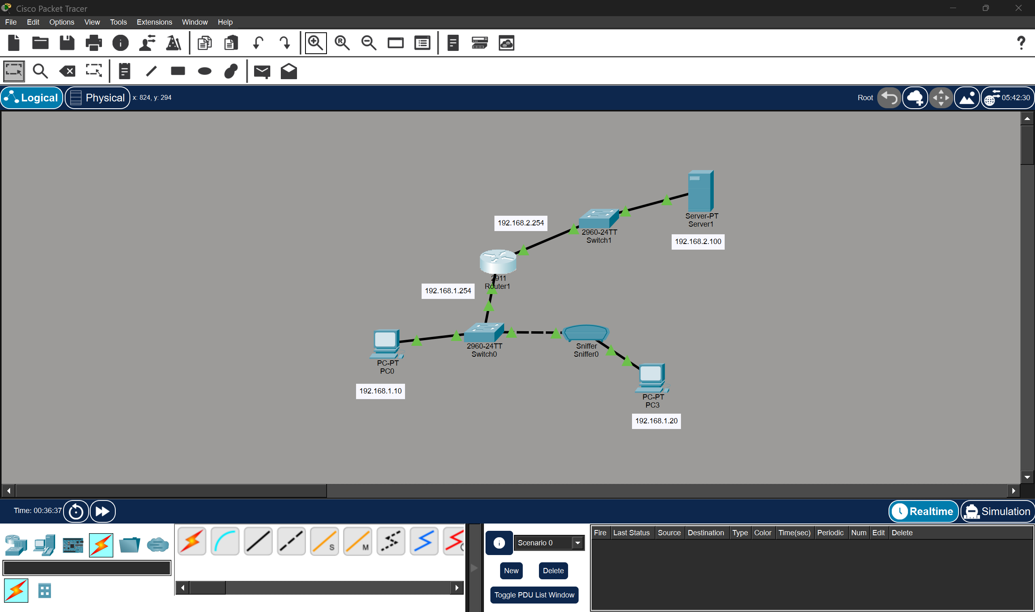
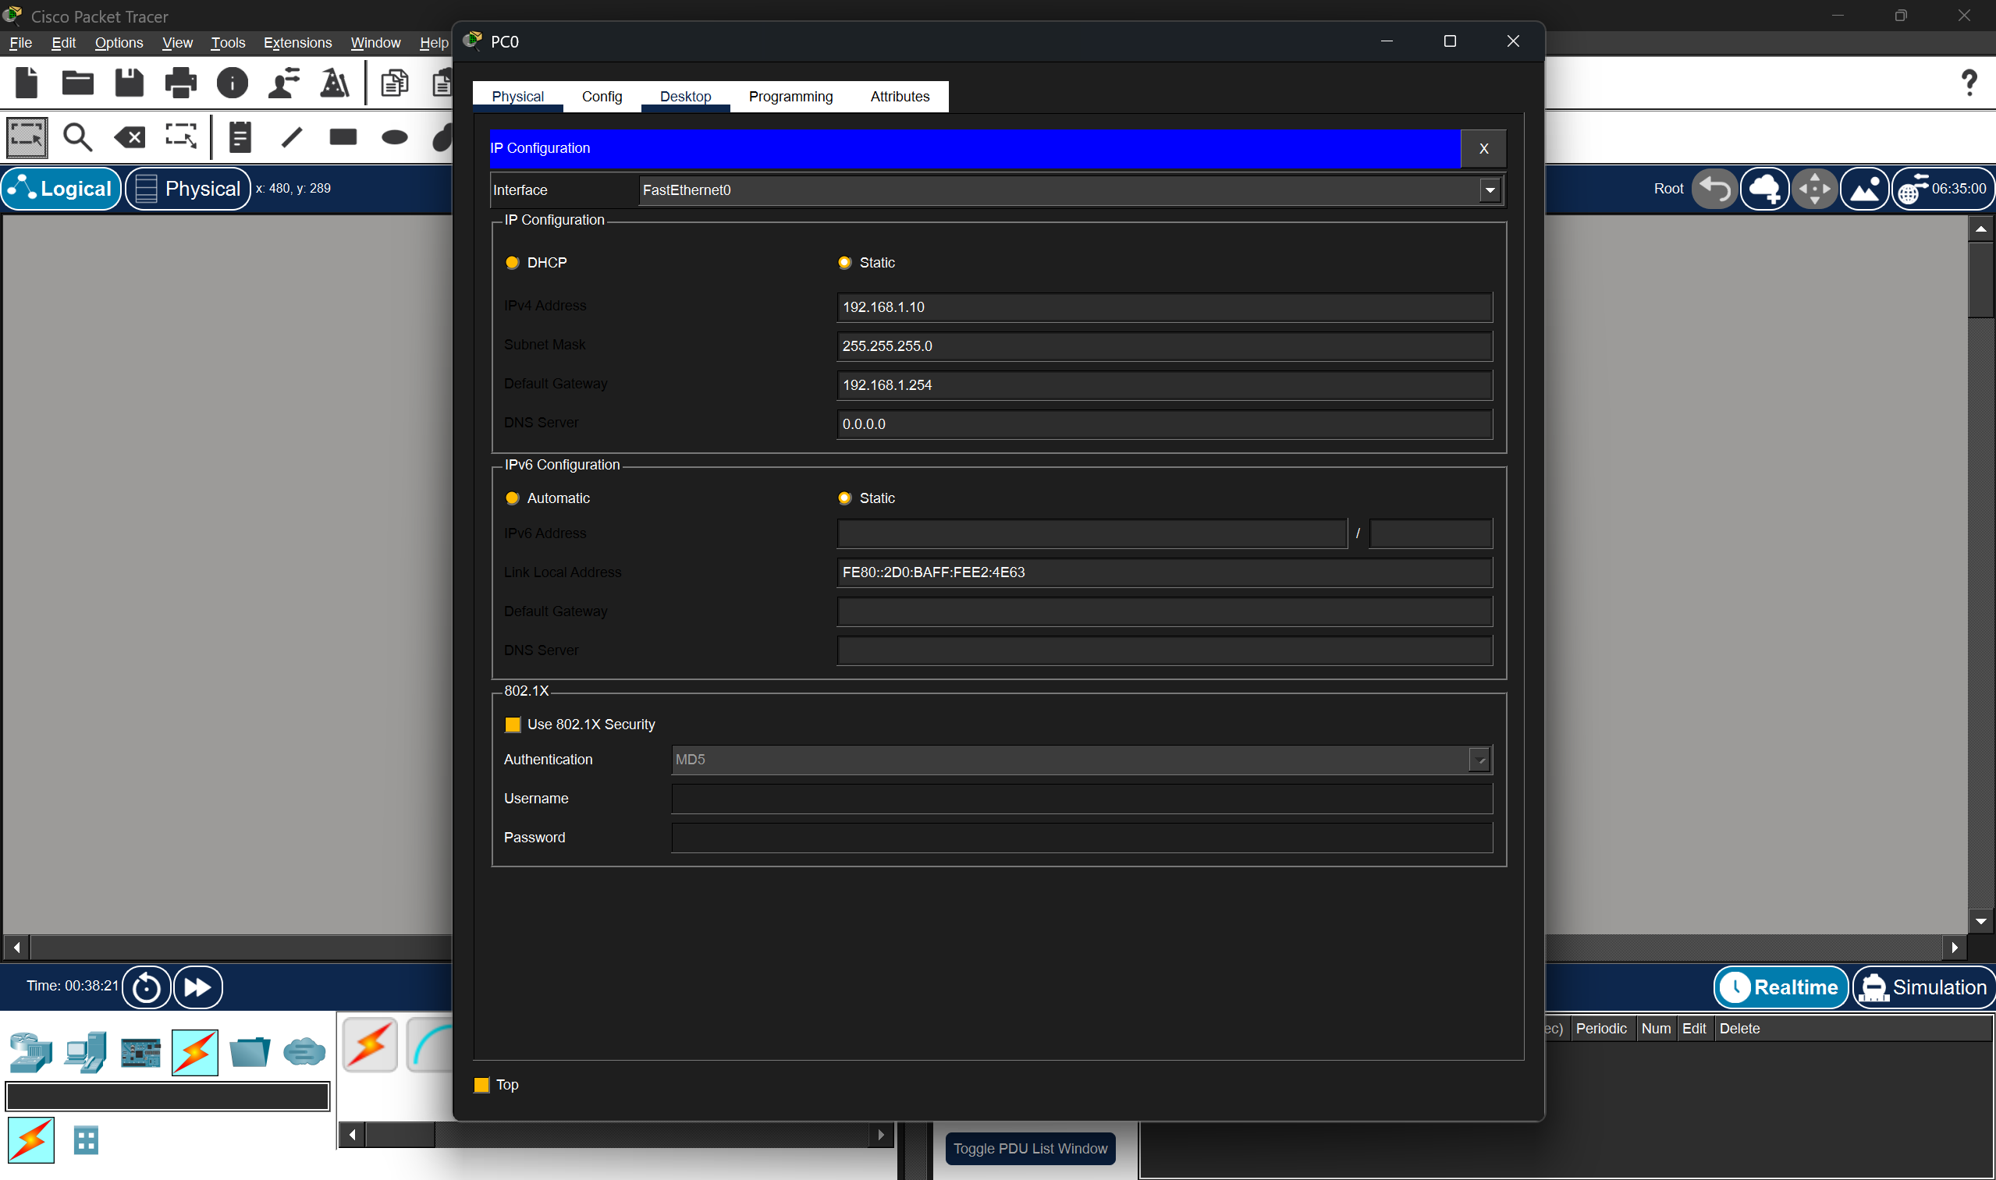
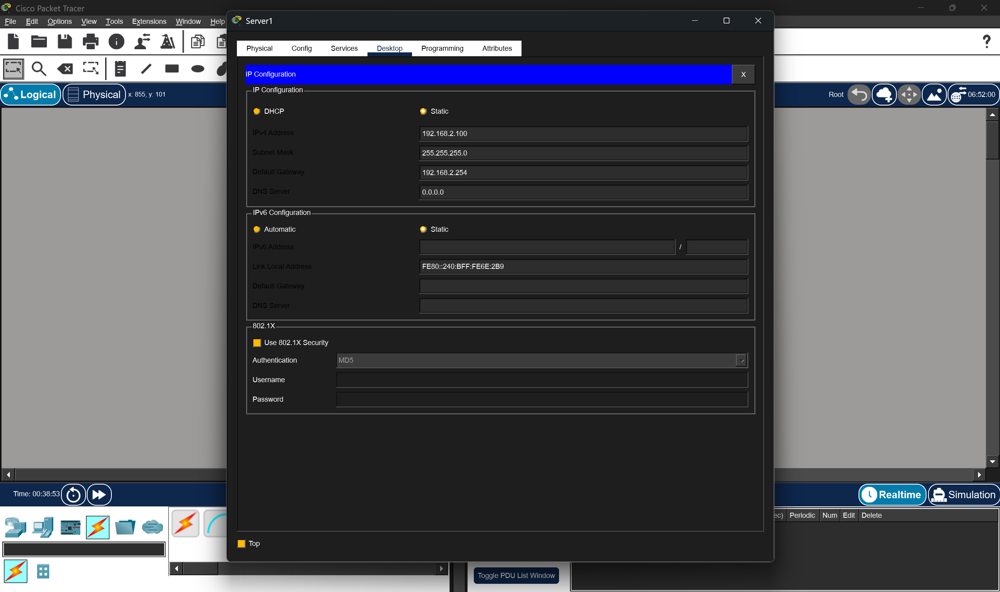
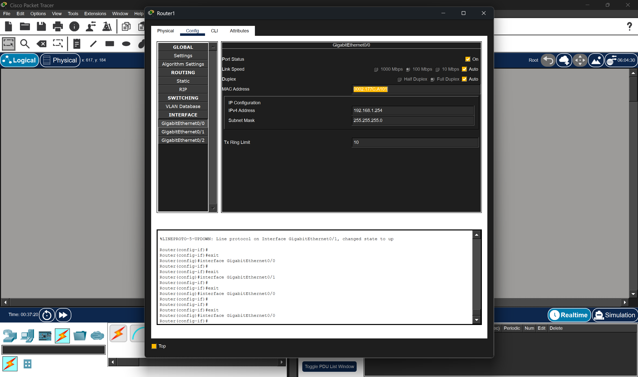
- Copying the MAC address of router 1 and pasting it into PC3

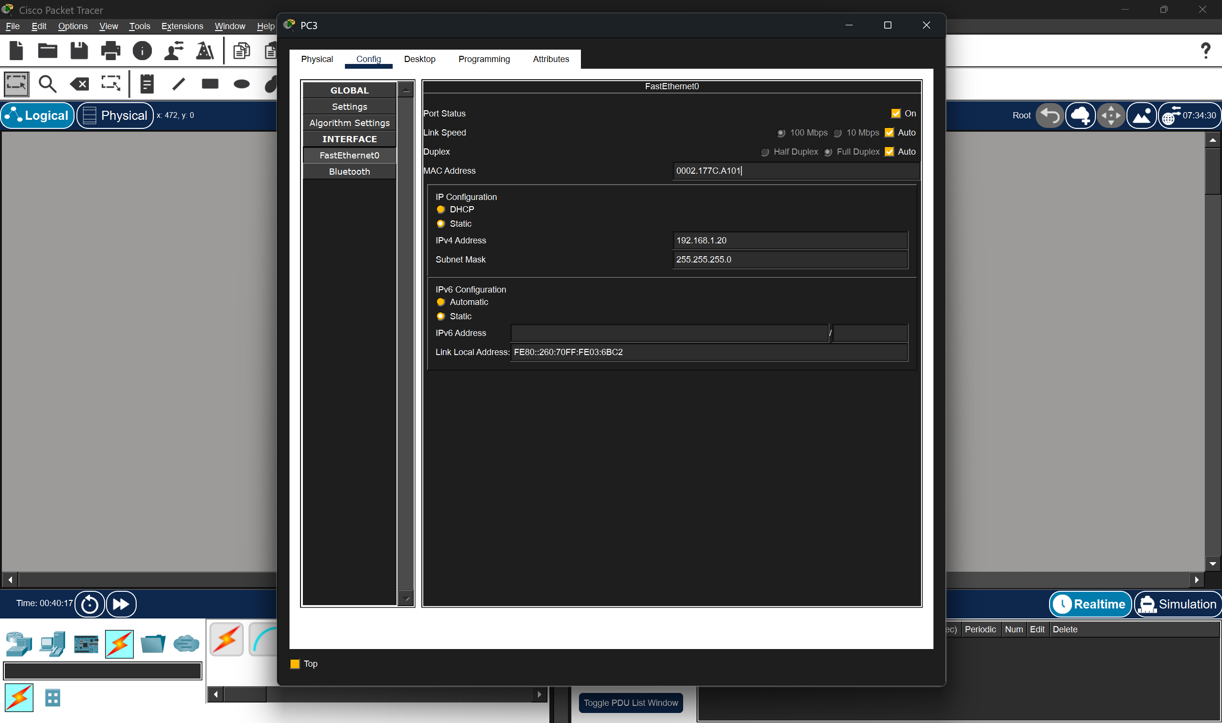
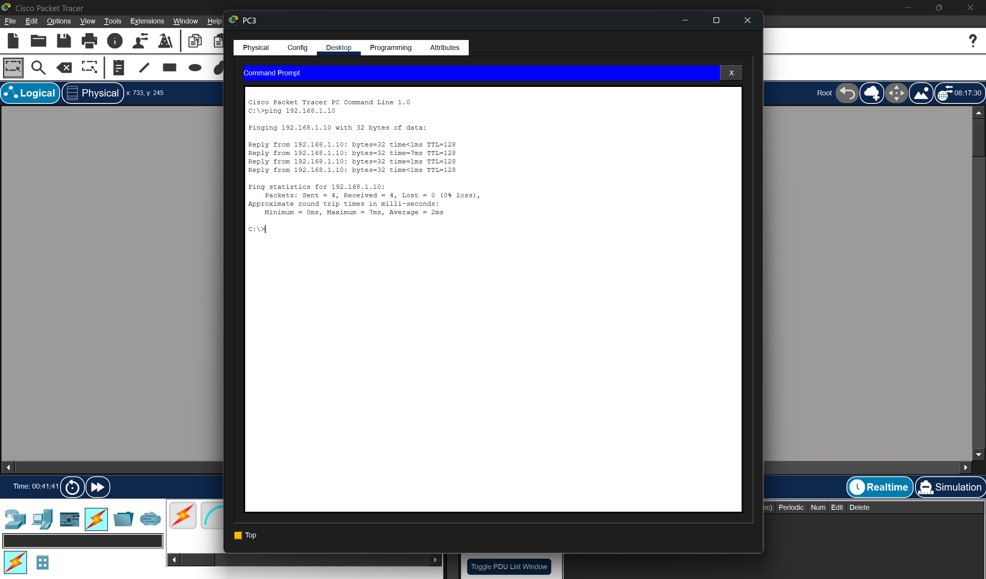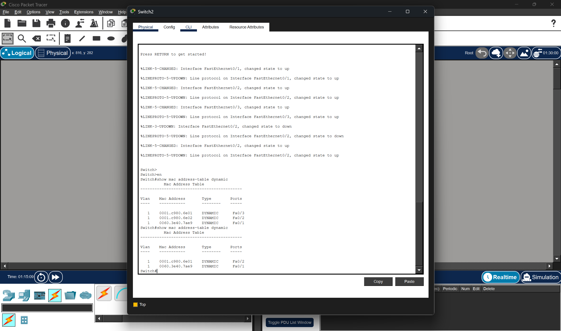
- We can see that the MAC address of default gateway is now the MAC address of the attacker.

